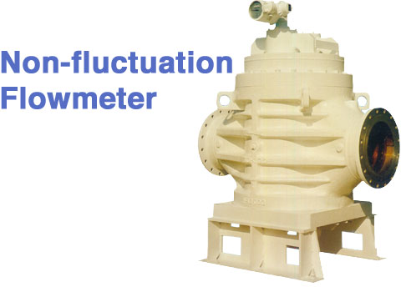

As the rotors’ rotation torque is small, pressure loss is minimum and it can a wide flow range.

2 sets of rotors at 45°alignment reduce the pulsation of flow achieving less vibration and noise of piping system.

Installation footprint is small because of Its vertical structure.

